EXPERIMENT 3: Create a prototype with familiar and unfamiliar navigation elements. Evaluate ease of use with different user groups using proto.io

NAME: VASANTH B REG NO: 240701820

AIM:
The aim of this experiment is to develop a Digital Library App prototype incorporating both familiar and novel navigation elements and to assess usability among diverse user groups using Proto.io.
PROCEDURE:

Step 1: Sign Up and Log In
- Go to https://proto.io

- Sign up for a new account or log in if you already have one.

Step 2: Create a New Project
- Click on “Create New Project.”

- Give the project a name (e.g., “Digital Library App”).

- Select the device type (Mobile – iPhone X).

- Click “Create” to start the project.

Step 3: Design the Login Screen
- Add a New Screen:

  - Click on the “+” button in the left panel.

○ Choose “Blank” and name it “Login”.

- Add Elements to the Login Screen:

  - Drag a Rectangle to create a header section.

○ Add Text widget and type the app name “LibraByte”.

○ Drag Text Input widgets for:

○ Email/Username

○ Password

○ Drag a Button widget and rename it “Log In”.

○ Add an Image widget to insert a book illustration.

- Add Interaction:

  - Select the “Log In” button.

○ Click on the Interactions tab (⚡ icon).
○ Click “+ Add Interaction.”

○ Set Trigger as “Tap”.

○ Set Action as “Navigate to Screen”.

○ Create a new screen named “Home”.

Step 4: Design the Home Screen
- Add Elements:

  - Change background color to dark blue.

○ Add profile image using Oval shape.

○ Add greeting text (e.g., “Hello User”).

○ Add Search Bar using Rectangle with rounded corners.

○ Add book cover images in horizontal layout.

○ Add genre icons (Fiction, History, etc.).

○ Add Bottom Navigation Bar (Home, Borrowed, Profile).

- Add Familiar Navigation:

  - Bottom Navigation Bar.

○ Visible Buttons.

○ Search Bar.
- Add Unfamiliar Navigation:

  - Add Swipe gesture to open hidden menu.

○ Add Long Press interaction on book image to show popup.

Step 5: Link Screens
- Select a book image on Home screen.

- Add interaction:

○ Trigger: Tap

○ Action: Navigate to new screen

○ Name the screen “Book Details”.

Step 6: Design Book Details Screen
- Add:

  - Back Button

○ Book Cover Image

○ Book Title

○ Author Name

○ Description
○ “Borrow Now” button

- Add Interaction:

  - Back Button → Navigate to Home.

○ Long Press on book → Show popup message.

Step 7: Preview the Prototype
- Click on “Preview” button at top-right corner.

- Test:

○ Login navigation

○ Home screen navigation

○ Swipe gesture

○ Long press interaction

Step 8: Conduct Usability Testing
- Define User Groups:

  - Group A – 18–22 years (High tech knowledge)

○ Group B – 30–40 years (Moderate tech knowledge)

○ Group C – 45+ years (Low tech knowledge)

- Assign Tasks:

  - Log in to the app.

○ Search for a book.

○ Open book details.

○ Use swipe gesture.

○ Navigate back to Home.

- Collect Feedback:

  - Measure task completion time.

○ Record errors made.

○ Collect satisfaction rating (1–5).

Step 9: Analyze and Evaluate
- Compare how different user groups interacted with familiar and unfamiliar navigation elements.

- Identify difficulties faced by users.

- Summarize findings and suggest improvements.

Output:

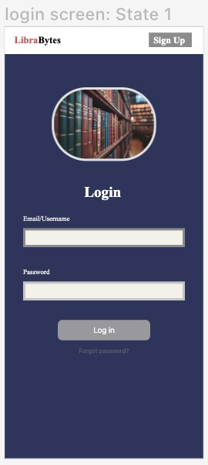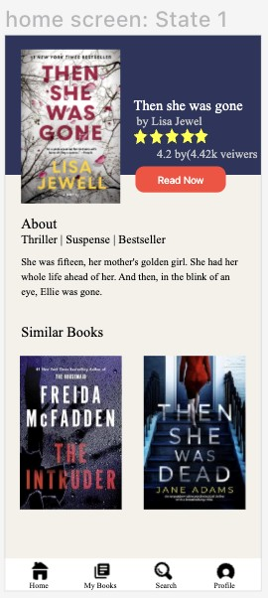

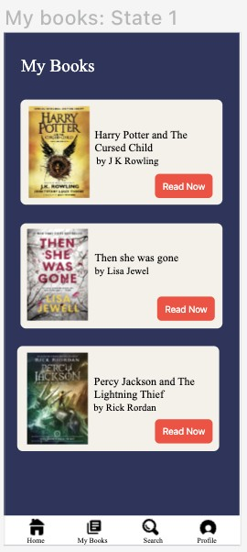

Prototype link:
https://pr.to/Q8GYME/

Result:
The Digital Library App prototype was successfully developed using Proto.io by incorporating both familiar and unfamiliar navigation elements.

